Weiler atherton polygon clipping algorithm

Algorithm of Weiler-Atherton Polygon Clipping
Step 1: First,create a list of intersection points that are in the starting or ending state. (I1, I2……. In).
Step 2: Now, create two more lists; one for subject polygon and other for clip polygon.Fill both lists with intersection points and vertices of the polygon.
Order of Subject Polygon list- Write down all the vertices of the polygon in the subject polygon column.
Order of Clip Polygon list – Write down the points of the clipping window.

Step 3: Insert the vertices in both lists in such a way that the intersection point exists between the correct vertices.
Step 4: Now, start from the first vertex of the polygon. Select the first intersection point as an entering point and follow the same process until we reach the exiting point.
Step 5: We can move from clip polygon list to subject polygon list and search for the finishing intersection point. Repeat the process until we find the entering point.
Step 6: Now, the polygon is being clipped. Repeat the same process until each point has been visited once.
Step 7: Stop

Example 1:

Consider a polygon with vertices ABCDEFG. Apply Weiler- Atherton algorithm to find the clipped polygon?

Solution: Let us assume that the vertices of window = C1, C2, C3, C4
The vertices of polygon = ABCDEFG
First, create two lists, one for subject polygon and second for clip polygon.
Iteration 1-
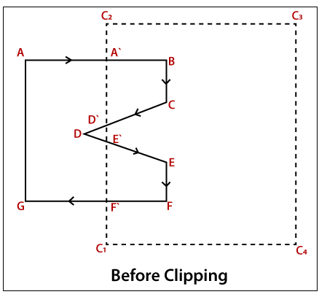.
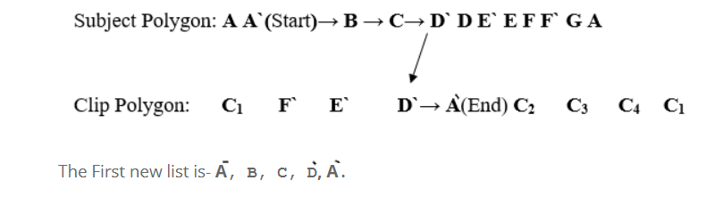

Iteration 2-
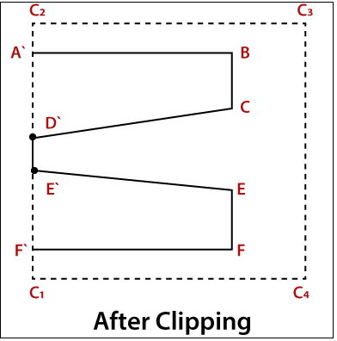
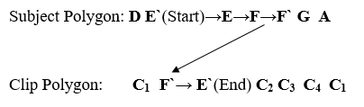

Example 2 :

1. Finding all the intersection points and grouping them
Here, let there be a polygon ABCD and another polygon VWXYZ. Let ABCD be the clipping polygon and let VWXYZ be the clipped polygon.

Subject polygon or clipped polygon
Clip polygon or Clipping polygon
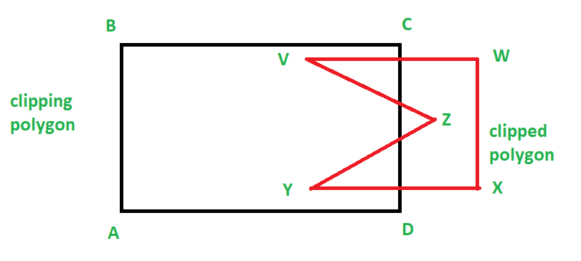
So, we can find the intersection points using any method.

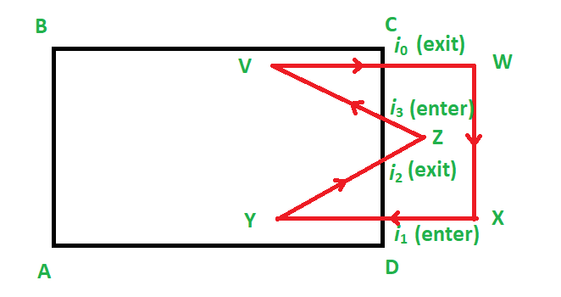

2. Making and filling of two lists

Now, we make two lists. One for the clipping polygon and one for the clipped polygon.
Now this is how we fill it:
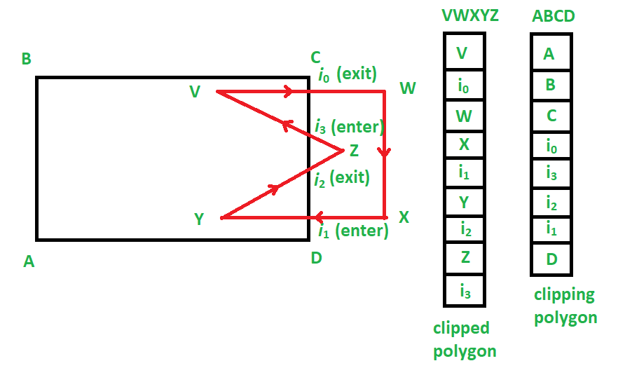

3. Running of the algorithm
We start at the clipped polygon’s list, i.e. VWXYZ.
Now, we find the first intersecting point that is entering. Hence we choose i1.
From here we begin the making of the list of vertices (or vector) to make a clipped sub-polygon.
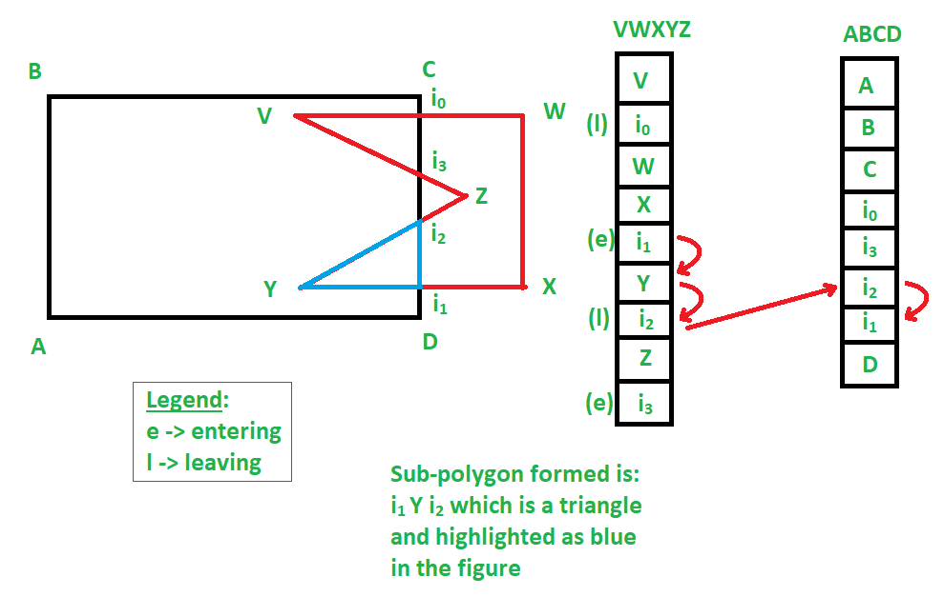
ccording to the given example, i1 Y i2 is a clipped sub-polygon.
Similarly, we get:
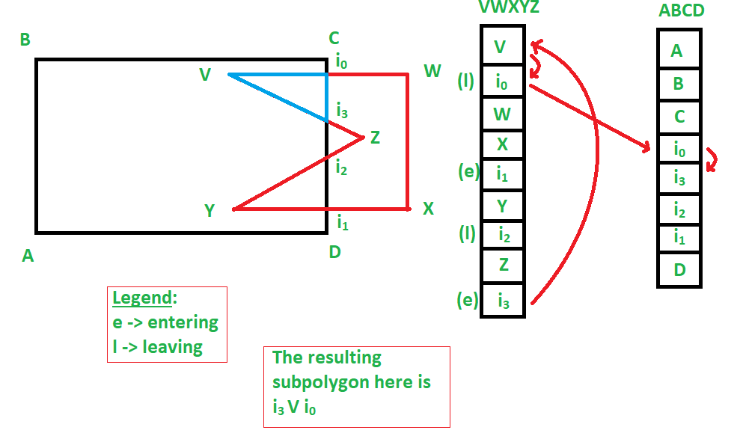

i0 V i3 as another sub-polygon also.
Hence, we were able to get two sub-polygons as a result of this polygon clipping, which involved a concave polygon, which resulted in:
